Milestone Two: Software Design Engineering Narrative (Enhancemnet1)
Karina Washington
Southern New Hampshire University
CS 499
November 10th, 2025

Overview of the Original Artifact for Enhancement 1
The original artifact selected for enhancement was my CS-330 Final Project, a 3D OpenGL application that rendered a realistic office desk scene from my husband’s office using textured 3D objects and directional lighting. The scene represented a modern workspace that included a computer monitor, keyboard, mouse, coffee mug, notebook, gaming mouse pad, and a wooden coaster. Each object was modeled using geometric primitives such as cubes, cylinders, and planes, then combined to form a cohesive environment.
Each object featured different materials and surface finishes. For example, the monitor and keyboard used smooth, reflective textures with subtle specular highlights, while the mug and coaster had matte materials to simulate ceramic and wood. Shadows and depth were achieved using OpenGL’s depth buffer, producing a realistic sense of spatial layering between the desk objects.
In the original version, the camera and lighting were static. While it demonstrated solid understanding of vertex and fragment shaders, the scene lacked interactivity, preventing the user from exploring the environment from different angles. This motivated my enhancement for the Capstone project
Enhancement Summary
For the Capstone enhancement, I implemented interactive camera and lighting control features to evolve the project from a static 3D render into an interactive simulation. The following features were added:
- Camera Orbit and Zoom Controls – Users can rotate around the desk scene using the arrow keys and zoom in or out using the Up and Down keys.
- Dynamic Light Intensity – Users can modify the scene’s brightness by pressing the “L” or “K” keys, simulating real-time lighting adjustments.
- First-Person View Mode – Through the new Camera.h and ViewManager.cpp classes, users can freely navigate using WASD keys and mouse movement.
- Optimized Shaders – The vertex and fragment shaders were refined to respond dynamically to user inputs, adjusting both projection matrices and light values in real time.
These updates required modifying multiple system components while maintaining code modularity, ensuring the enhancement integrated seamlessly into the project’s existing architecture.

Justification
This enhancement demonstrates software design and engineering proficiency, aligning with CS-499 Outcome 3: “Design and evaluate computing solutions using sound engineering principles.” By incorporating real-time input and refactoring the graphics pipeline, the project now uses object-oriented design patterns to separate rendering, input processing, and camera control into distinct modules. This structure enhances readability, maintainability, and scalability for future development mirroring professional 3D engine design practices used in tools like Unity or Unreal Engine. Furthermore, by improving camera behavior and shader-based lighting, this project better showcases my understanding of both CPU-side application logic and GPU-side rendering processes, two critical competencies in computer graphics engineering.

Implementation Details
- Scene Composition:
The desk environment consists of multiple geometric meshes. For example, the desk plane is a scaled rectangular mesh, while the monitor and keyboard are constructed from scaled cube primitives. Smaller details like the mug handle use partial torus segments and cylinders. Each object is positioned and scaled using transformation matrices defined in SceneManager.cpp.
- Material and Texture Mapping:
Each surface is linked to a specific texture tag and material definition using the OBJECT_MATERIAL structure. The project employs textures for the wood desk, black plastic monitor casing, and white ceramic mug, achieving a realistic combination of diffuse and specular reflection values.
- Interactive Camera System:
A Camera class was implemented to handle view transformations. The camera supports real-time rotation, translation, and zoom using user input captured through GLFW. The view matrix updates each frame to simulate motion and orientation changes.
- Lighting Enhancement:
The ShaderManager was extended to include a new uniform parameter lightIntensity, enabling smooth adjustment of brightness. The fragmentShader.glsl file dynamically scales color output by this intensity, simulating lighting variation.
- Main Application Loop:
The main loop (Main.cpp) continuously processes user input, updates camera and lighting states, and re-renders the scene using double-buffered frame updates for fluid motion. Depth testing and blending ensure accurate object layering and semi-transparent effects.

Reflection and Course Outcomes Connection
This enhancement connects directly to CS-499 Outcome 1 (Design and implement computing solutions using algorithms and data structures) and Outcome 3 (Apply software engineering and design principles to develop maintainable systems).
By introducing real-time camera and lighting controls, I demonstrated an advanced understanding of transformation matrices, event-driven programming, and shader-level lighting models. I also improved the architecture by decoupling rendering logic from input handling, following industry-standard practices such as the Model-View-Controller (MVC) pattern.
Through this project, I gained deeper insights into how mathematical transformations directly influence rendering output. Debugging shader behavior and camera motion improved my ability to analyze 3D coordinate systems and GPU-based computation. These skills strengthen my readiness for professional work in software engineering, game development, or graphics programming.

Lighting Implementation and Realism
Lighting plays a crucial role in realism within any 3D scene. In this project, I enhanced the visual depth of the desk environment by refining the fragment shader to calculate ambient, diffuse, and specular components more accurately. The ambient term provides a base level of light to ensure that all surfaces are partially illuminated, while the diffuse and specular terms respond dynamically to user-controlled intensity values.
According to Xu and Shen (2012), real-time lighting in OpenGL “allows developers to simulate physical light behavior by manipulating intensity, attenuation, and reflection properties within the shader pipeline,” which is exactly the principle applied in this enhancement. Likewise, Zotti, Neumann, and Purgathofer (2005) emphasize that effective light approximation directly affects how users perceive object material and depth, a concept that guided my approach to refining the ceramic mug’s matte surface and the glossy reflections on the monitor. These refinements collectively elevate the user’s experience, aligning the lighting system with modern rendering principles that merge physical accuracy with interactive control.
Visual

Here is a picture of the original set up from my husband’s desktop that I recreated in 3D. This was my result from my creation of object in 3D.
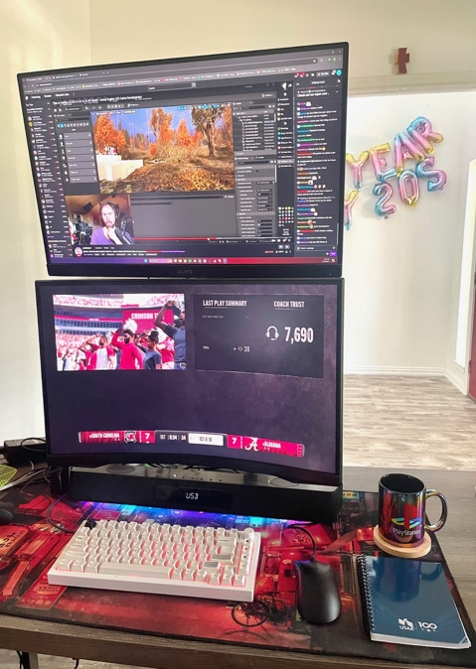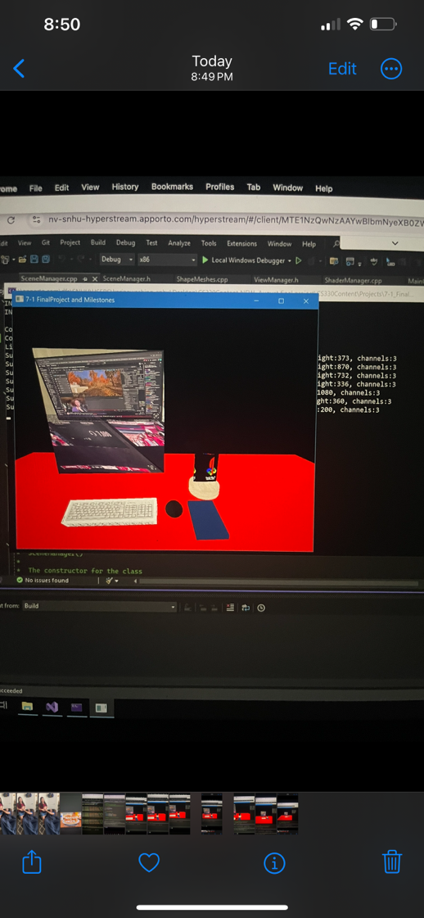

Conclusion

Enhancing the CS-330 OpenGL project elevated a static 3D scene into an interactive and visually engaging experience. By implementing real-time camera orbit controls, adjustable lighting, and modular shader management, the project demonstrates a higher level of technical skill in computer graphics and software design. These improvements enhanced both the visual realism and the usability of the 3D desk environment, showing how dynamic lighting and camera systems can transform a simple render into an immersive simulation.
This enhancement also highlights professional competencies such as modular programming, object-oriented architecture, and the integration of GPU and CPU processes. Through these refinements, the project bridges academic learning and real-world software engineering practices, aligning closely with the goals of the CS-499 Capstone by showcasing mastery of interactive system development and computational problem-solving.

References
Palermo, F. (2009). OpenGL lighting [Lecture slides]. Carnegie Mellon University. https://www.cs.cmu.edu/afs/cs/academic/class/15462-s09/www/lec/02/lec02b.pdf
Xu, J., & Shen, Z. J. (2012). Research of lighting technology based on OpenGL. Advanced Materials Research, 588–589, 2113–2116 https://doi.org/10.4028/www.scientific.net/AMR.588-589.2113
Zotti, G., Neumann, A., & Purgathofer, W. (2005). Approximating real-world luminaires with OpenGL lights. WSCG 2005 Short Papers Proceedings. https://www.cg.tuwien.ac.at/research/publications/2005/zotti-2005-lum/zotti-2005-lum .pdf

